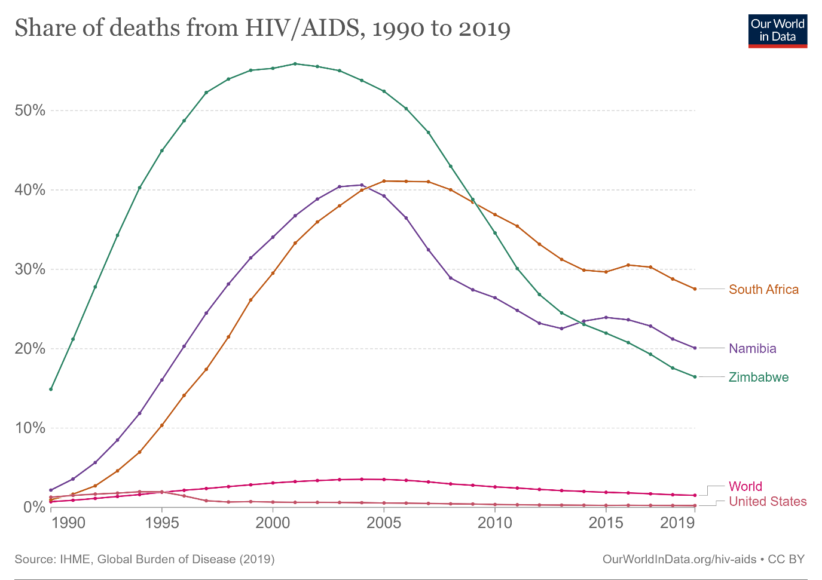

## 1. (What?) Description of the Dataset and Attributes:

The chosen visualization presents data on the number of deaths due to AIDS (acquired immunodeficiency syndrome) worldwide over time. The dataset contains ordered temporal data and quantitative data representing the number of deaths. Each data point corresponds to a specific year and is associated with a country or region and the number of AIDS-related deaths.

### Type of Datasets and Attributes:

* The datasets used in this visualisation consist of two main attributes:
  + **Time (Ordered Quantitative Data)**: The x-axis represents time, spanning from 1990 to 2019.
  + **Share of Deaths from AIDS (Ordered Quantitative Data)**: The y-axis represents the percentage of deaths attributed to AIDS in each region and income group. The values here are continuous and range from 0% to 50%.
* **Qualitative Data**: The data is categorised into different regions (e.g., South Africa, United States etc.).

## 2. Why?

This visualization is interesting and non-trivial because it combines ordered and quantitative data with qualitative data to provide a comprehensive overview of the global AIDS share of death rate. The use of line plots with small circles at data points enables interactive and detailed exploration of the data.

## 3. (How?) Marks and Channels Used:

### Marks:

Line: The primary mark used in this visualisation is the line. Each line represents the trend of the "Share of Deaths from AIDS" over time for a specific region, which allows users to observe trends and patterns over time.

### Channels:

* Horizontal Position (X-axis): The X-axis represents time, allowing users to see the progression of AIDS-related deaths over the years.
* Vertical Position (Y-axis): The Y-axis represents the number of deaths, a quantitative value, allowing users to understand the scale of the epidemic for each country or region.
* Colour: Each line plot is colour-coded based on the country or region it represents, using distinct colours for each entity. Colour is a qualitative channel, enabling users to differentiate between various regions easily.

The visualization is designed as an interactive line plot, with each line representing a specific country or region. Users can hover over the lines or data points to view more detailed information, allowing for easy exploration and comparison between different regions. The colour coding enhances the visual distinction between regions, aiding in pattern recognition and analysis.

Source of the Visualization:

The visualization can be found at the following link: [Share of deaths from HIV/AIDS, 1990 to 2019 (ourworldindata.org)](https://ourworldindata.org/grapher/share-deaths-aids?tab=chart)